Customer Shopping Behavior Analysis

1. Project Overview

This project focuses on analyzing customer shopping behavior using retail transaction data. The main objective is to understand how customers make purchasing decisions, identify popular products, and discover trends in spending habits. These insights can help businesses improve customer experience, increase sales, and make better marketing decisions.

2. Dataset Summary

The dataset contains 4,000 customer purchase records with 20 features related to customer details, products, and transactions.

Key Features:

- Customer information such as age, gender, and membership status.

- Product details including category, item purchased, and price.

- Transaction details like purchase amount, payment method, and shipping type.

- Customer behavior such as previous purchases, review ratings, and discount usage.

Data Quality:

- Checked for missing values and duplicate records.

- Cleaned the dataset to ensure accurate analysis.

3. Exploratory Data Analysis Using Python

- The analysis started with data preparation and exploration using Python.

- Steps Performed:

- Imported the dataset using the Pandas library.

- Examined the structure of the dataset using info() and describe().
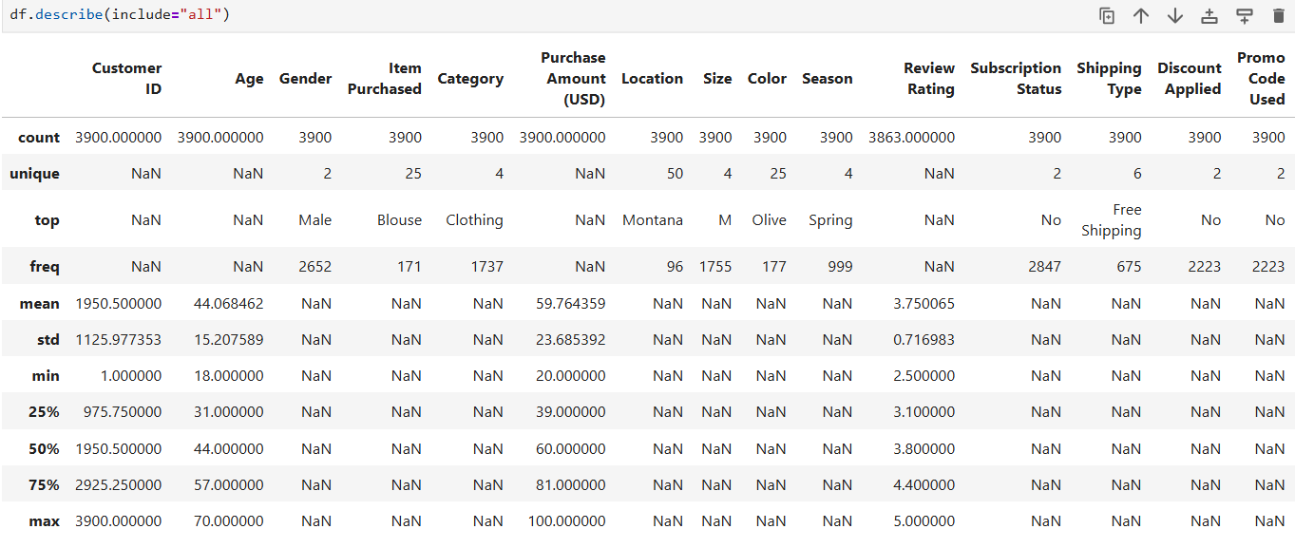
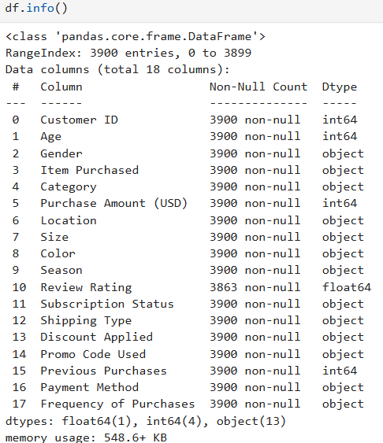

- Checked for missing values and handled them using suitable techniques.
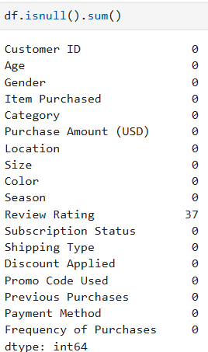

- Renamed column names into a consistent format for better readability.
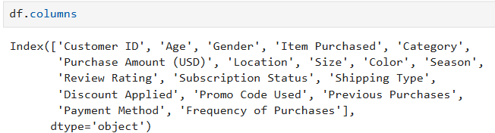

Removed duplicate records to improve data quality.
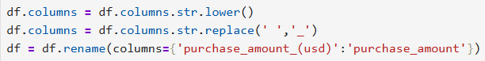
- Created new features such as customer age groups and purchase frequency for deeper analysis.
- Verified data consistency before proceeding with further analysis.
- This process ensured that the dataset was clean, organized, and ready for analysis.

4. Data Analysis Using SQL

After cleaning the data, it was loaded into PostgreSQL to answer important business questions.
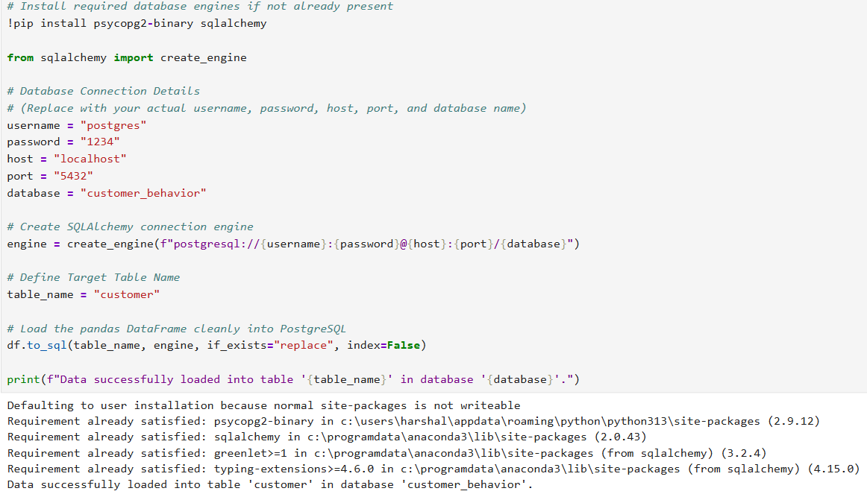

The SQL analysis included: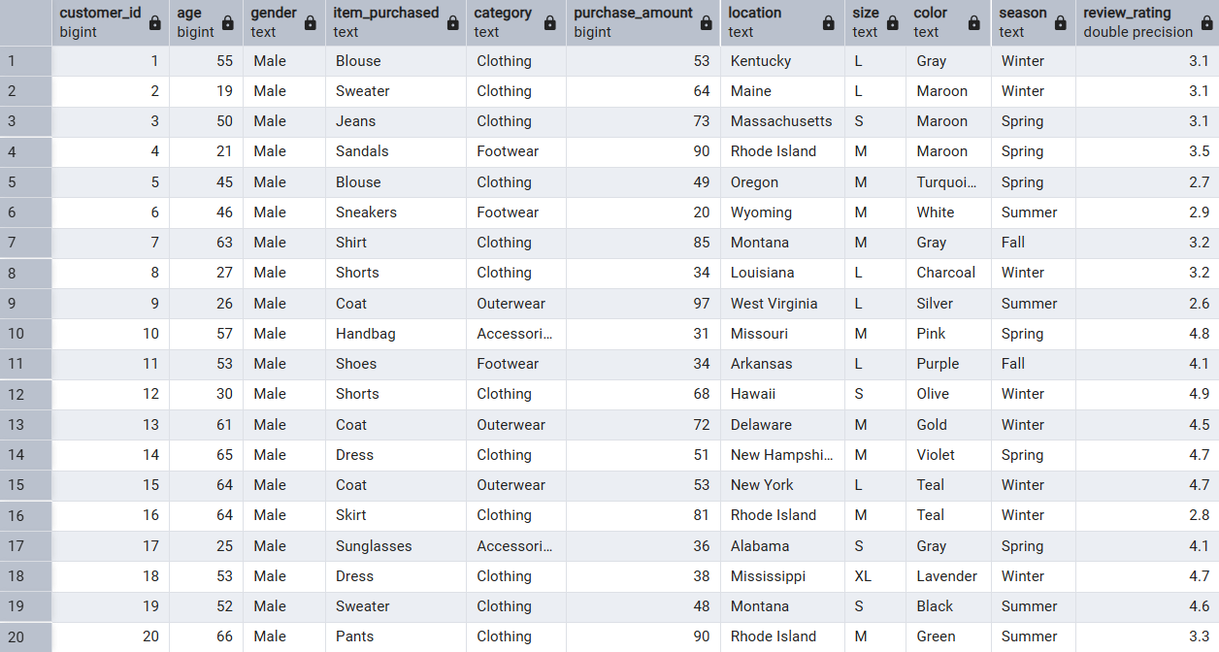
1. total revenue earned separately from male and female customers.
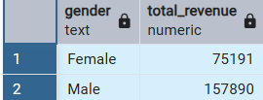

2. Find the customers who received a discount but still spent more than the overall average purchase amount.
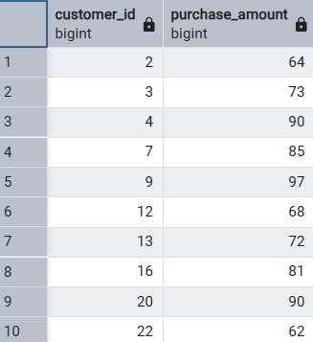

3. List the top 5 products based on their average customer review ratings.
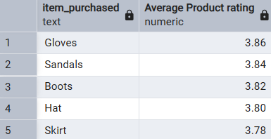

4. Show a comparison of the average purchase amount for Standard Shipping and Express Shipping.
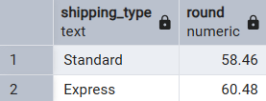

5. Analyze whether subscribed customers spend more than non-subscribers by comparing their average spending and total revenue.
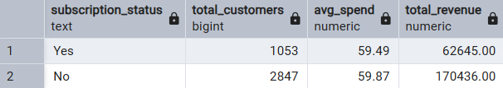

6. Identify the top 5 products with the highest percentage of purchases where a discount was applied.
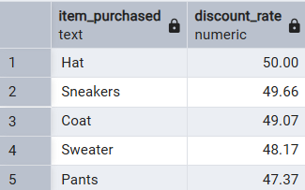

7. Classify customers as New, Returning, or Loyal according to their previous purchase count, and display the number of customers in each group.
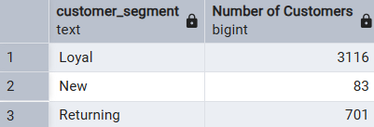

8. Determine the three most frequently purchased products in every category.
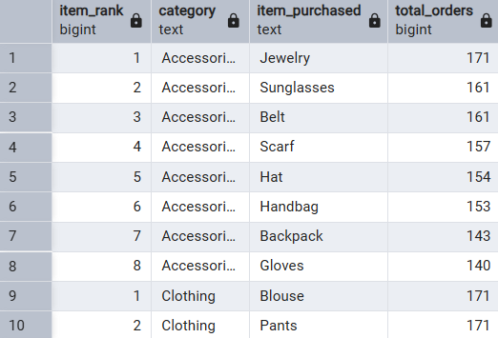

9. Check whether customers with more than five previous purchases are more likely to have a subscription.

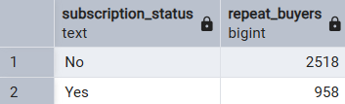
10. Calculate the percentage contribution of each age group to the overall revenue.
SQL helped convert raw data into meaningful business insights.
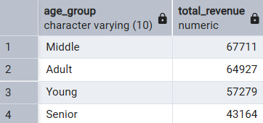

5. Key Insights

- The analysis revealed several useful findings:

- Customers in certain age groups contributed more to overall revenue.

- Some product categories consistently generated higher sales than others.

- Loyal customers made more frequent purchases and spent more on average.

- Discounts encouraged purchases but should be managed carefully to maintain profitability.

- Customers choosing faster shipping options generally had higher purchase values.

- Highly rated products attracted more customers and performed better in sales.

5. Dashboard in Power BI
Finally we built an interactive Power BI Dashboard to presents insights visualization.
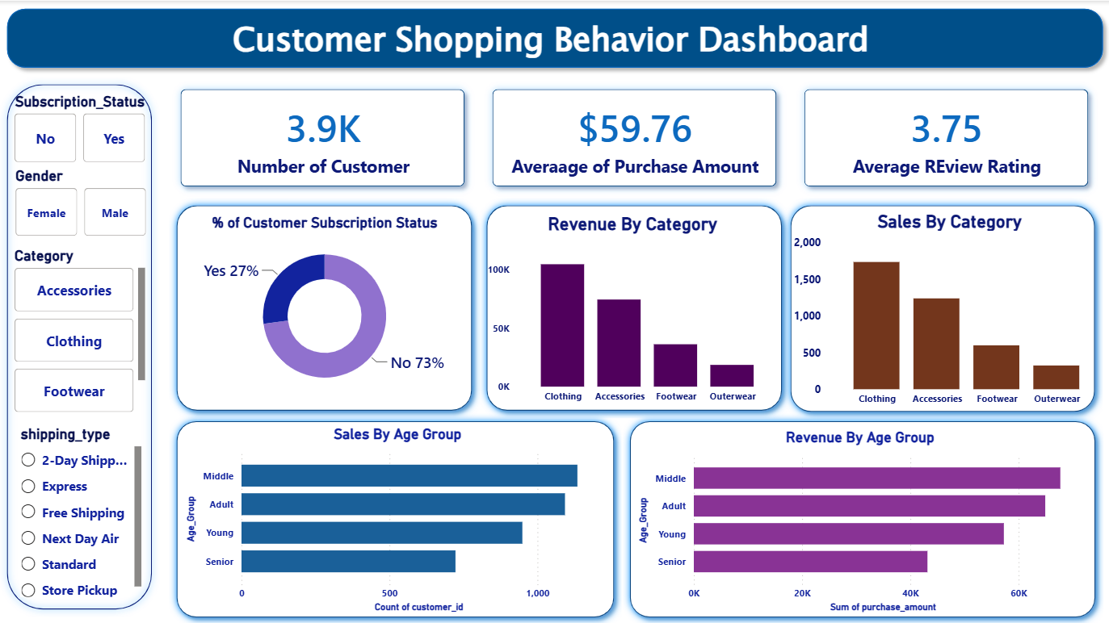

6. Business Recommendations

- Based on the analysis, the following recommendations are suggested:

- Introduce attractive membership benefits to encourage more customer subscriptions.

- Launch loyalty programs to reward repeat customers.

- Use targeted marketing campaigns for high-value customer segments.

- Promote top-selling and highly rated products through advertisements.

- Review discount strategies regularly to balance customer satisfaction and business profit.

- Improve personalized product recommendations based on customer purchase history.

7. Conclusion
- This project demonstrates how combining Python, SQL, and Power BI creates a powerful data analytics workflow.
- By using Python for data cleaning and SQL for database querying, we turned raw data into insights.
- To bring these findings to life, we built an interactive dashboard
- This visual tool tracking 3.9K customers serves as a central hub for business decision-makers.
- It highlights key metrics, including an average purchase amount of $59.76.
- The visuals clearly show that Clothing is our dominant category in both sales and revenue.
- Additionally, Middle-aged and Adult groups represent our highest-spending customer segments.
- With 73% of customers currently non-subscribers, there is a massive opportunity for growth.
- Targeting this specific segment with loyalty programs could unlock significant untapped revenue.
- Ultimately, this framework empowers the business to confidently replace guesswork with data-driven strategies

